Book Club - Booking Instructions

Each Book Club Can:
- Book up to 6 months (180 days) in advance
- Borrow 2 Book Club Sets at a time
- Have a maximum of 7 bookings on their online account
- Loan each title for a maximum of 6 weeks (43 days)

Making a booking on the Libraries ACT website:
- Before making a booking, you will first need to log in to your book club account on the Libraries ACT website. (If this is your first-time logging in, please use the temporary password you have received via email).

- Under Dashboard there is an option called Book Club Sets, which will only appear for Book Club accounts. When you select this option, there will be two ways to find Book Club Sets to borrow:

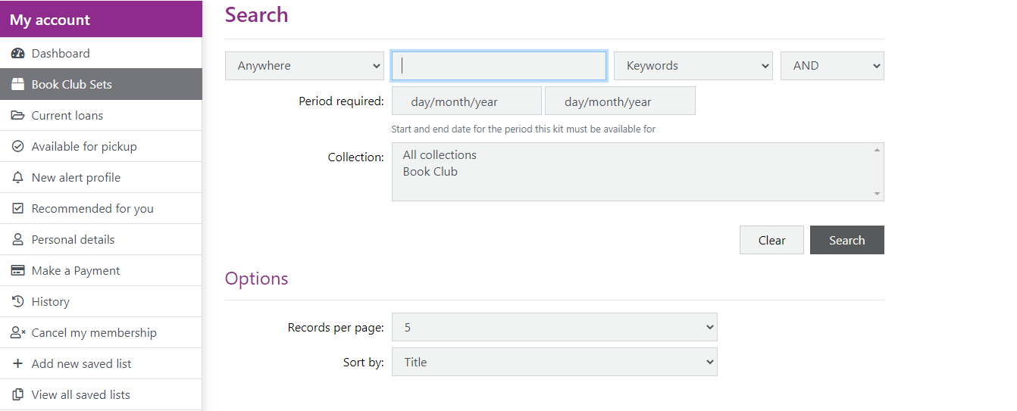
      - To Find a Particular Set: Enter a book title into the Anywhere field and choose Book Club in the Collection field. Click Search.

(Please visit our website for the complete list of Book Club titles).

      - Browsing available Sets in the collection: You can browse the book club collection by entering your desired loan dates in the Period required field, and then selecting Book club in the Collection field.
When you are ready, click Search. (This will only bring up titles that are available for your chosen period.)
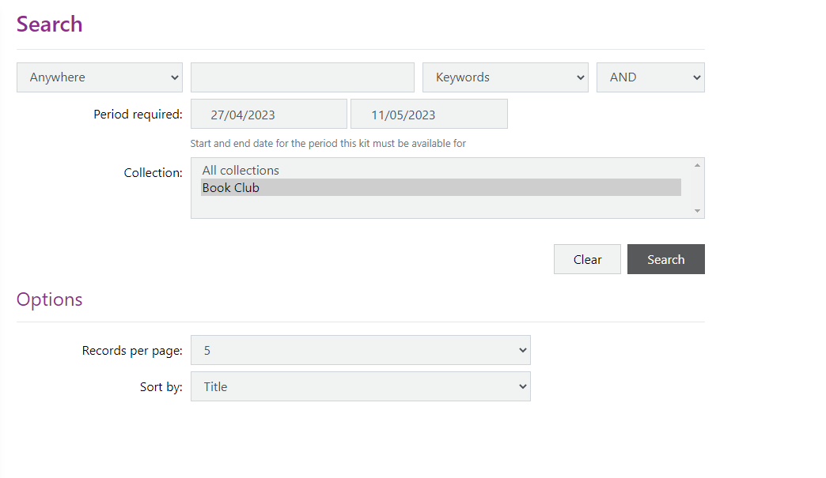

- A list of Book Club Sets will now be listed alphabetically on your screen.
- When you have found the title of your choice, click on its title.

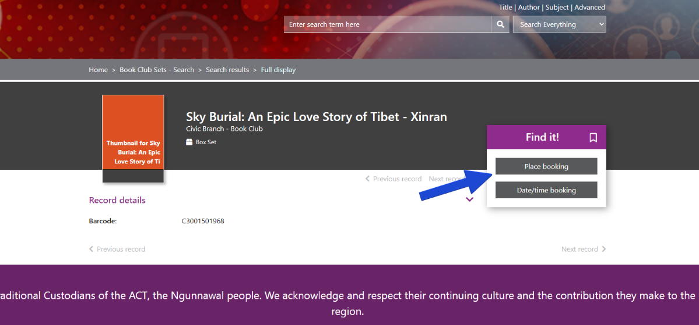
- When the screen loads, you will see the option to Place booking. Click here to place your booking.

- This will take you to a calendar booking system.
- The calendar has the capacity to show 180-days (6 months) worth of booking slots.
- The first 3 months will be automatically load onto your screen. For example, if today’s date is 30th October 2023, all dates within October, November and December will be displayed.
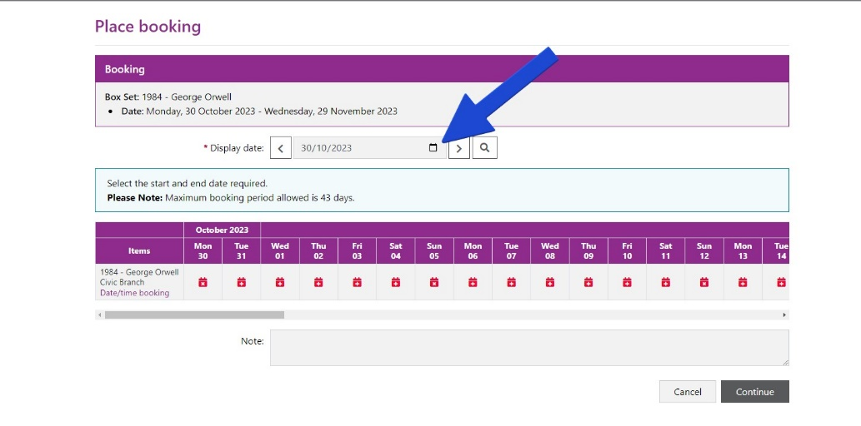
To view dates beyond the 3-month mark, click the calendar icon in the “display date” field at the top of the screen.

- A miniature calendar will now appear. Click (only once) the date you would like to start your booking. Your screen will now automatically load the appropriate month.
For example:
Jane logs on to her online account on 30th October 2023 and wants to make a booking to begin on the 1st February 2024. She clicks the 1st February in the miniature calendar and lets her screen automatically load. Now her screen displays every date within February, March and April.

- To make a booking, select the start and end dates of your desired loan period.
- Available dates are not coloured.
- Unavailable days are in red. Please see the below image for reference:
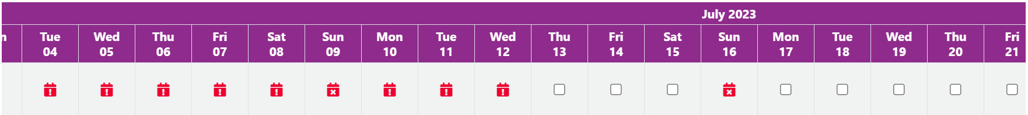

- Please note that public holidays and Sundays will also show up in red (this is because not all branches are open on these days). You cannot start or end a booking on these days.

- If possible, please make your bookings at least 1 week before your pickup date. This is to allow for our staff to transport the books to your desired collection branch.
- Once you have chosen your desired dates, simply click Continue.
A confirmation screen will then appear. Please check your selected dates and click Continue if you are satisfied.

- You will then see the below screen. This means your booking has now been completed!
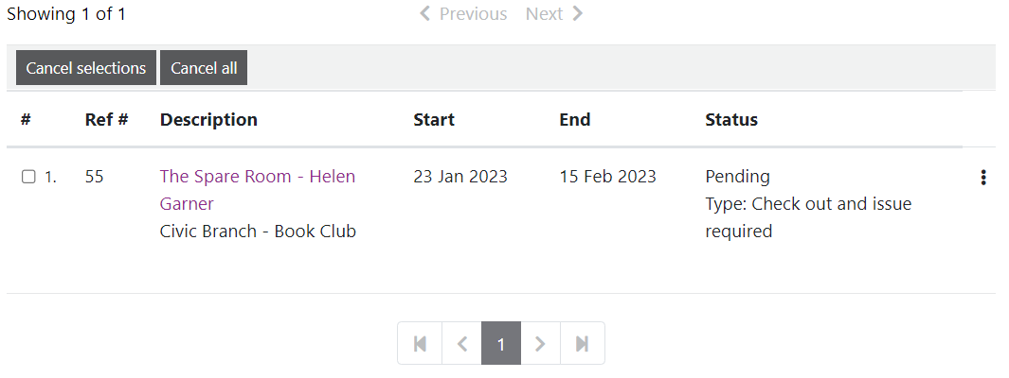

Cancelling a booking:
To cancel a booking online, click on the Dashboard icon and click on Bookings.
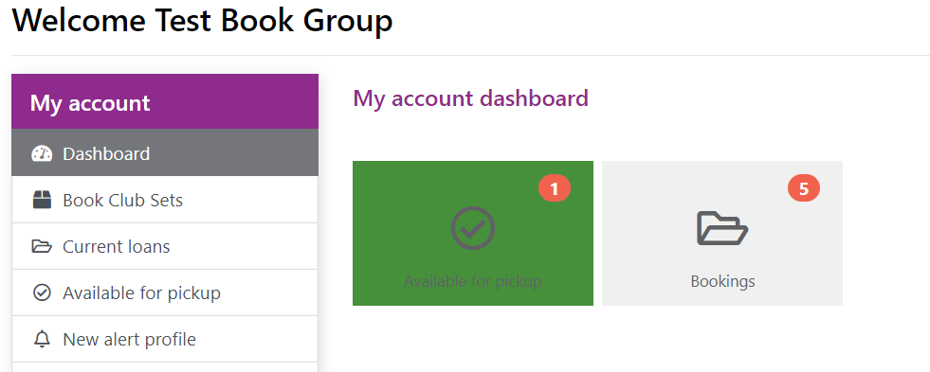

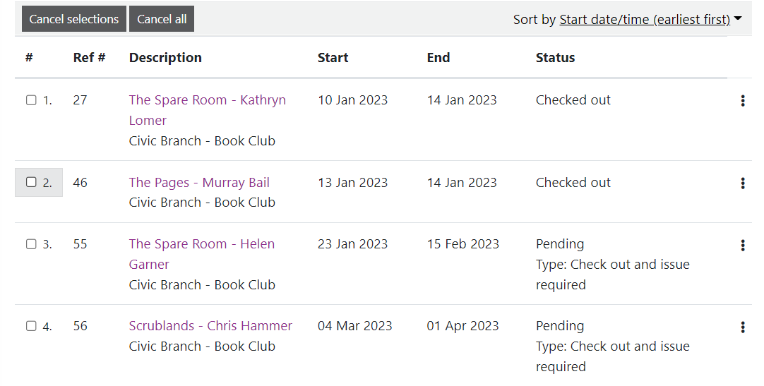
If you only want to cancel one booking, please tick the box next to the title you want to cancel and click the Cancel selections button. If you want to cancel all bookings, please click the Cancel all button.

