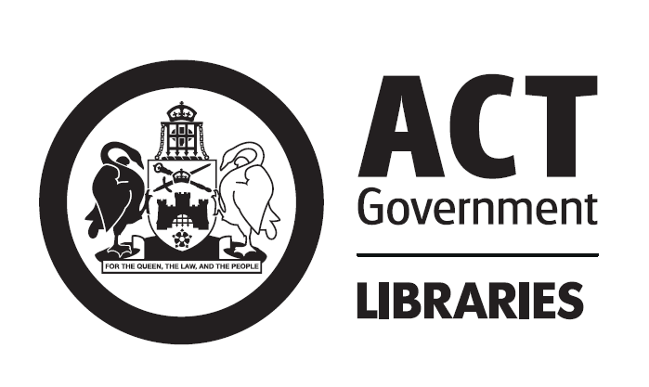

Young People in the Library
Libraries ACT is committed to serving the information and recreation needs of children and teenagers (both referred to here as young people¹). The library welcomes customers of all ages, and provides targeted resources and programs for young people.

The library has a duty of care to ensure the safety of customers and staff, and enjoyment of the library by all. A commonsense approach to customer service is recommended at all times. The library requires that customers take responsibility for their behaviour or actions while on library premises. The behaviour of young people on library premises is the responsibility of the young people themselves, their parents/carers, any responsible person accompanying them and if in a school group, their teachers, supervisors and the school which they attend.

Young people in the library have the right to:
- Intellectual freedom
- Equal access to a full range of free resources, services and programs available to other users
- A wide range of free resources, services and programs developed to meet their diverse needs and interests
- A library environment that complements their physical and developmental needs
- Trained and knowledgeable staff specialising in services for young people
- Welcoming, respectful and supportive service for all ages
- Policies that address and include the diverse needs and interests of young people

Access to resources
Library resources are available to all library users without restriction, except where legally required, or as set out in the Libraries ACT Loans Policy. It is not the responsibility of Libraries ACT or its staff to exercise a supervisory or restrictive role in determining which library resources young people may use or access. The library encourages parents/carers to set their own family rules in consultation with their child. It is the responsibility of parents/carers to monitor young people’s selection and use of library resources.

The Library exercises no limitation on access to publications, videos, DVDs, CDROMs or CDs, except where material is classified as restricted under the Classification (Publications, Films, and Computer Games) Act 1995 (Cth), or as set out in the Libraries ACT Loans Policy. The Library has no censorship role in its choice of the resources that form the library collection. Under the Classification (Publications, Films, and Computer Games) Act 1995 (ACT) it is an offence to sell, let or hire category 2 restricted publications, films, music or games classified MA or above to a minor. The library may request identification with proof of age from users before loaning legally restricted material.

The Library protects the public’s right to know, and does not monitor or control the content of materials offered through the Internet. Filtering software is used to restrict access to some content (eg web sites categorised as promoting violence or pornography). Library staff are available to assist customers in the use of the Internet, and to recommend web sites on particular subjects. A number of appropriate databases and web sites have been selected for inclusion in the Library’s electronic collections.
Parents/carers are responsible for their child’s use of the Internet, in line with the Conditions of Use for Public Library Internet Access Services.

Unsupervised children
Unsupervised children can be at risk in any public place, including public libraries. Library staff do not supervise children in the library, so there is a risk that unsupervised children may leave the library at any time, hurt themselves, or be approached by strangers. We recognise that individual families may judge their child/ren old enough to be left alone or supervise younger children. However, parents/carers should be aware of the issues involved when the child/ren are unsupervised.
Libraries are busy public places, open to all, and staff cannot judge which members of the public present a possible danger to children. Young children left alone in a library can become distressed, bored or disruptive. Libraries do not have the facilities to attend to children who are sick, injured or hungry. In order to provide a safe and enjoyable service for all, the library recommends that parents/carers remain present and within sight at all times, including during programs, to supervise their children.

Photographs
The Library often takes photographs: as a record of events; for use in publications and on our web site; and to publicise our services and resources in other ways. They may also be sent to the news media. The Library will obtain written permission from parents/carers to use photographs of their child/ren.

Further information
Information related to young people’s rights and public libraries is also available from:
- ACT Department of Education, Youth & Family Services http://www.decs.act.gov.au/
- ACT Office of the Community Advocate http://www.oca.act.gov.au/
- Libraries ACT Loans Policy http://www.library.act.gov.au/
- Libraries ACT Collections Policy http://www.library.act.gov.au/
- ALIA Statement on Free Access to Information 2001 http://www.alia.org.au/policies/
- ALIA Statement on Public Library Services to Young People in Australia 1992 http://www.alia.org.au/policies/
- Children and Young People Act 1999 http://www.legislation.act.gov.au/
- Office of Film and Literature Classification http://www.oflc.gov.au/splash.html
- NAPCAN http://www.napcan.org.au/
- SCALEplus Law Resource http://scaleplus.law.gov.au/
- UNESCO Public Library Manifesto 1994 http://www.ifla.org/documents/libraries/policies/unesco.htm
- UNICEF Convention on the rights of the child http://www.unicef.org/crc/fulltext.htm

¹ For the purposes of this policy the term young people will be used to refer to both children and teenagers. Under the Children and Young People Act 1999, a child is a person who is under 12 years old, and a young person is a person who is 12 years old or older, but not yet an adult.

