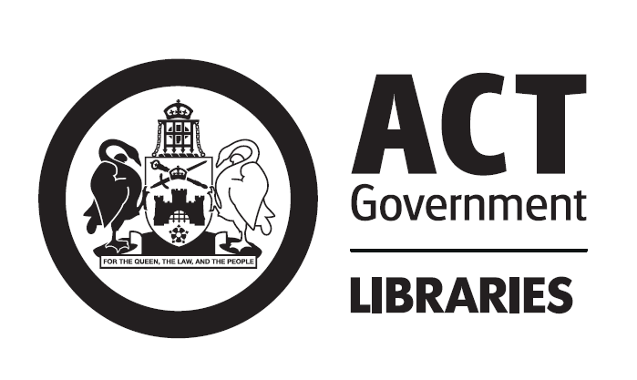

Conditions of use for public library internet access services
Welcome to the ACT Government's Public Library Internet Access Service.
This service is made available to you as part of the Library's continuing commitment to the highest level of service to the community, equitable access and service policies, intellectual and recreational freedom and the freedom of access to information.
To ensure that all users can access the wealth of information and services on the Internet, we ask that you observe the following conditions of use.
Public Access Internet terminals are provided for information, study and social networking. Online recreational games and chat services are permitted.
Time limits apply to Internet terminals as they are often heavily used. To ensure availability you may pre-book sessions to use an Internet terminal. Bookings may be made for up to two 30 minute sessions per day. Bookings can be made up to two days in advance. If no prior bookings exist you may use the terminal at other times; check with library staff at the start of each session. Normal time limits apply to those customers using public internet access terminals for online recreational games, and a limit of 2 customers per terminal for this purpose applies.
Terminals designated for 'Senior's Access' provided at the Woden and Belconnen libraries can only be pre-booked by those over 60 (proof of age may be required) between 10am and 4pm Monday to Friday. These terminals may be utilised by other users when not pre-booked by a senior.
Printing facilities are available for a fee. Users must abide by the copyright laws when using material on the Internet.
Proceeding to book a Public Access Internet Terminal is evidence of the fact that you have read, understood and accept these Conditions and will abide by the Library's terms. In other words once you book access to these Internet services you are bound by these Conditions and the following indemnity.

Conditions of use
These Conditions of Use must be strictly adhered to. In the event of any breach of these Conditions the Library reserves the right to immediately terminate your use of the facility and to maintain that restriction for as long as the library chooses.
Legal prosecution may result from a breach of these Conditions.
Satisfactory proof of your age and identity may be required and must be provided as requested.
For the purpose of this policy the word Material includes any data, information, text, graphics, animations, speech, videos, and music or other sounds, accessible electronically - including any combination or selection of any of these.
- Use of electronic resources
  - Much of the Material on the Internet is protected by Australian and international intellectual property rights. Intellectual property represents the property of someone's mind or intellect and owners of this property have the exclusive right to determine who may use the property and on what terms and conditions. Many of the terms are referred to on the Internet. If there is no specific reference the law will prevail and implied licences and other conditions or restrictions may apply.
  - You are only permitted to use this technology in accordance with:
    - the laws that protect the property; and
    - the laws that govern the technology; and
    - these Conditions.
1.3 You should not assume that you can reproduce, print, transmit, or download all Material to which you have access. You have rights to use Material consistently with the technology or the rights of the owner of the Material. You may reproduce Material only where it is expressly stated that you may, or where it is a normal function of that technology (for example accessing Material on a bulletin board which can only be read if it is down loaded).
- Prohibited and unlawful use
  - Internet terminals are not to be used for any activities of an illegal or fraudulent nature, including such activities as defined under the Telecommunications Act 1997 (Cwlth), or other applicable Territory and Commonwealth laws.
Some activities are unlawful or unacceptable and therefore PROHIBITED on library computer terminals. Unlawful or unacceptable activities include - but are not limited to:
    - gaining access to any material that is pornographic, offensive or objectionable.
    - engaging in any conduct that offends Federal or Territory laws and regulations.
    - harassment (sexually or otherwise) of another person.
    - engaging in any defamatory message - including forwarding a defamatory message of which you are not the author.
    - sending or forwarding any material that is abusive, sexist, racist, pornographic, offensive or illegal
    - engaging in activities of an illegal or fraudulent nature
- COPYRIGHT WARNING
In using the Library's technology or equipment the Library does not authorise you to infringe (unlawfully interfere with) the intellectual property rights of any material. It is entirely your obligation to ensure that you operate within the legal system.
  - Check for a copyright notice or other information to determine what you can do with the material. If it is not clear that you are allowed to use the material the way you may want to, you must contact the copyright owner.
  - Copyright law is designed to protect and reward creativity and intellectual endeavour. Copyright protection is available automatically when the works are committed to writing that may be on paper, on disk, on tape and any other medium including any electronic form of the material.
  - A copyright owner has the right to control the use of their material: to prevent use and to negotiate payment for copying, reproducing, using and so on. If you infringe the owner's rights in the material the owner may take legal action against you.
  - If you reproduce protected material without the permission of the copyright owner you may infringe copyright and other rights such as trade marks and business name rights.
  - Reproducing even a part of the work may amount to an infringement of rights if the part you have reproduced is important - it need not be a large part.
  - Users should note section 40 of the Copyright Act 1968 (Cwlth), which refers to fair dealing.
  - Information on the Copyright Act 1968, its amendments and other intellectual property matters is available at the website of the Attorney-General’s Department at www.ag.gov.au.
- Access to services and internet content
  - The ACT Government is not responsible for material available on the Internet and cannot guarantee the authority or accuracy of any of the information found on it, nor can it accept responsibility for any material it contains which may be considered offensive by some users.
  - 4.2.1 Library staff are here to help you access the wide variety of material available on the Internet. Library staff are required to work within the law and in particular, the Broadcasting Services Act 1992 (Cwlth)
  - Public libraries are places for all of the community and use of the internet must be made in that context. Public libraries are also workplaces for library staff and the standard of acceptable use in a workplace also applies. Therefore, library staff are able to require users to leave websites deemed unsuitable for a public place or workplace.
  - Documents relevant to the Broadcasting Services Act 1992 are available at the website of the Department of Broadband, Communications and the Digital Economy. Library staff will take appropriate action if a user is found to be accessing the internet outside of the law.
  - The Library accepts no responsibility for the supervision of minors' use of these services.
    - Adults responsible for minors must exert their own safeguards and controls.
    - Please note that for the purposes of these Conditions, anyone under the age of 18 is considered a minor.
  - The Library does not control the content or layout of any material on any website. Nor does the Library make any representation or warranty about relevancy, accuracy, quality, or validity of any material and you must make that judgment for yourself. Some material you access may require you to divulge personal details and credit information: you do so at your own risk.
  - The Australian Broadcasting Authority (ABA), an independent federal statutory authority responsible for the regulation of digital broadcasting and Internet content in Australia, provides the Cybersmart Kids Online site to help children and their families use the Internet.
  - The Australian Broadcasting Authority handles complaints concerning Internet content through its complaints service.
  - You use these facilities at your own risk.

- No guarantee of privacy
  - As access to this service is provided in a public place and through publicly available facilities you should be aware that no guarantee of privacy can be made, either while you are using the facility or after you have completed your session through access by others to history files, etc.
  - In addition no guarantee can be made concerning the privacy or security of any information provided through this facility.

Notice of indemnity
You acknowledge that in the event that any legal action is threatened or commenced the Australian Capital Territory bears no responsibility whatsoever for the conduct or outcome of the legal action, arising out of or connected with your use of this Internet service. You also agree to indemnify the Territory against any and all damages, costs and expenses arising out of any action, settlement or compromise, arising out of or connected with your use of this Internet service.
Proceeding beyond these Conditions is evidence of the fact that you have read, understood and accepted these Conditions and will abide by the Library’s terms. In other words if you use the Public Access Internet Service you are bound by these Conditions and the indemnity.

