Guide to Borrowing eBooks for Book Clubs
Please note that eBooks are subject to availability. Different loan/renewal conditions may apply. You must be a registered member of Libraries ACT to borrow eBooks.
- Go to librarycatalogue.act.gov.au. Type ‘RBdigital’ into the search bar and select ‘Online resources’ from the dropdown menu to the right of the search bar.

- Click on the link for ‘More…’
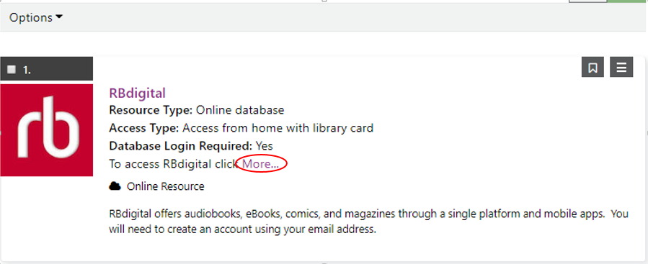

- If you don’t have an account with RBdigital you will need to register. Register using your own Libraries ACT card number (not the Book Club’s) and your email address.
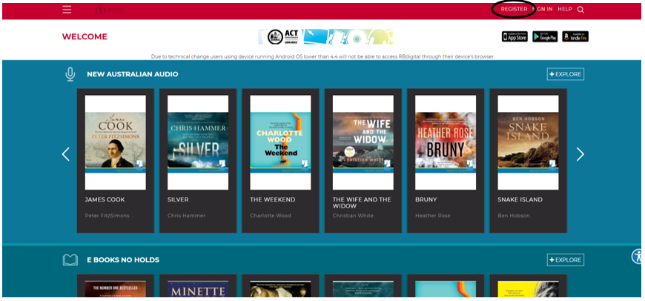

- Once you have signed in, look for the collection called ‘E BOOKS NO HOLDS’. This collection of titles can be checked out by multiple borrowers simultaneously.
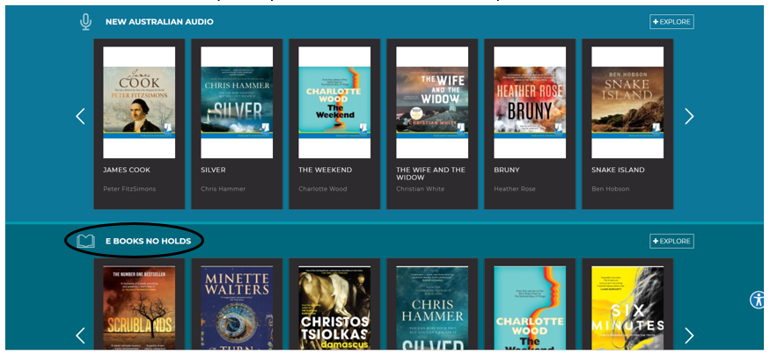

- Click on any title to view more details or to check out the item. The loan period is 21 days. If you need more time, you may renew your loan.
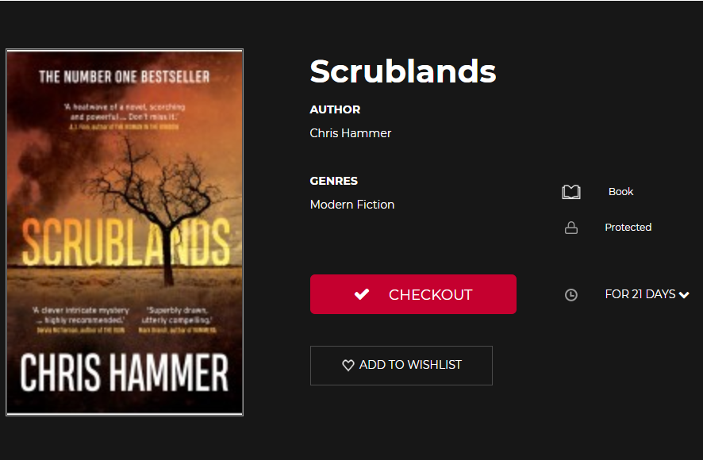

- eBook apps for RBdigital are available for iOS, Android, and Kindle Fire.

